Solving N-Queens problem using

Hill Climbing Search and its variants

Programming Project 2

Intelligent Systems

Submitted By-

Sahil Rasane(801135252)

1. Problem Formulation-

The N-queens problem consists of placing n number of queens on a nxn chessboard in such a way that no two queens can attack each other. Thus the solution requires that no two queens are not in the same row, column or diagonal. There is no solution for the problem when n=2 and n=3.

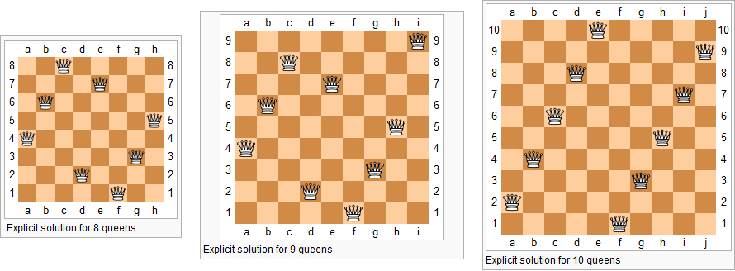

1. Approach-

We are going to use hill climbing search and its variants to solve this problem. 1 Represents a queen and 0 represents empty space.

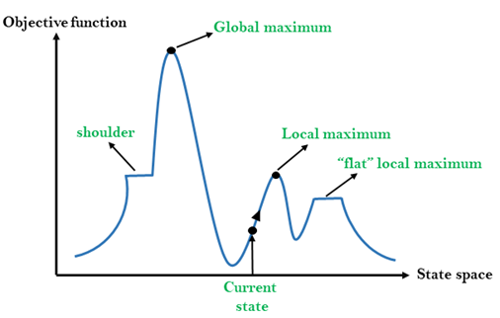

1. Hill Climbing Search-

Hill Climbing Search is an optimization technique which is a type of local search technique. It is an iterative algorithm that starts with an arbitrary solution to the problem, then attempts to find a better solution by making an incremental change to the solution. If the change generates a better solution, another incremental change is made to the new solution and so on, until no further improvements can be found.

1. Hill Climbing with Sideways Move-

Hill Climbing search can run into problems like a shoulder as shown in the figure, where there exists a better solution than the one selected now but is hidden beyond a set of solutions which have the same value as that of the solution which is selected now. In this case we may miss out on a better solution. So to combat this problem we are using the sideways move. We are limiting the number of sideways moves possible so that our program may not get stuck in a loop when there doesn’t exist a solution better than the current one.

1. Hill Climbing with Random Restart –

Another approach to counter the problem of hill climbing search running into a shoulder or a local maxima is to use the random restart method. In this method we randomly use the values to obtain a better solution than the current one. This method is a trial and error method which keeps trying to get a better solution by randomly taking values from the range of possible solutions.

1. Functions-

board(): Generate a chess board with randomly placed queens.

heuristic(): Calculate the queens in conflict.

compare(): Compare the current and new heuristic value selecting the lower one.

steepest_ascent(): Function to implement Hill climbing using steepest ascent.

sideways_move(): Function to implement sideways move.

random_restart_sideways(): Function to implement random restart using sideways move.

random_restart_without sideways(): Function to implement random restart.

1. Source Code-

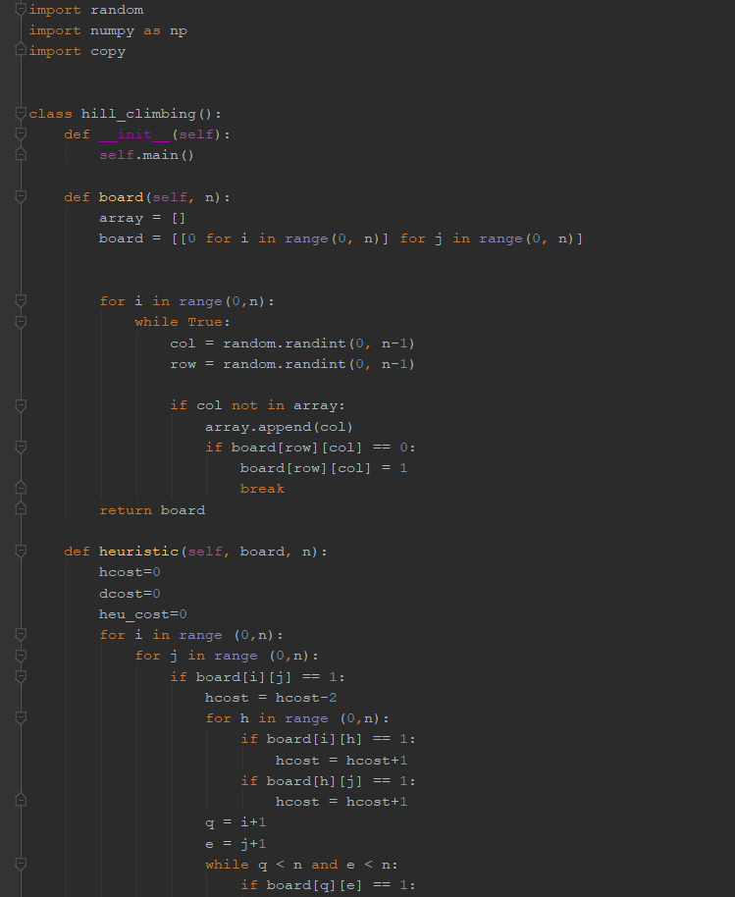

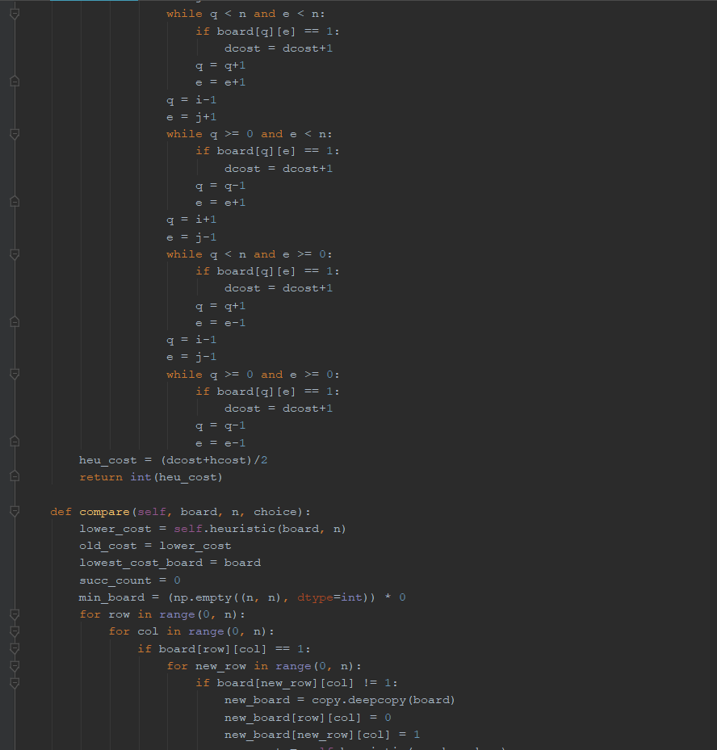

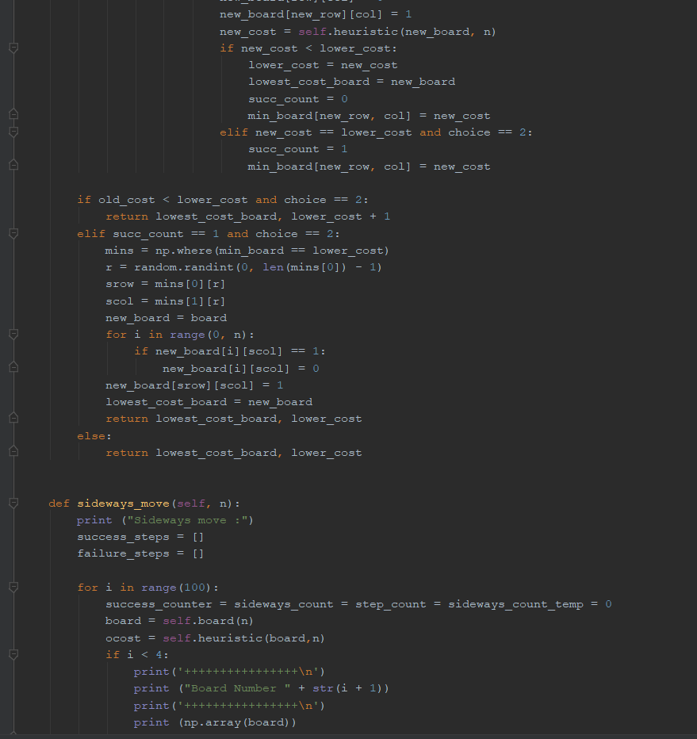

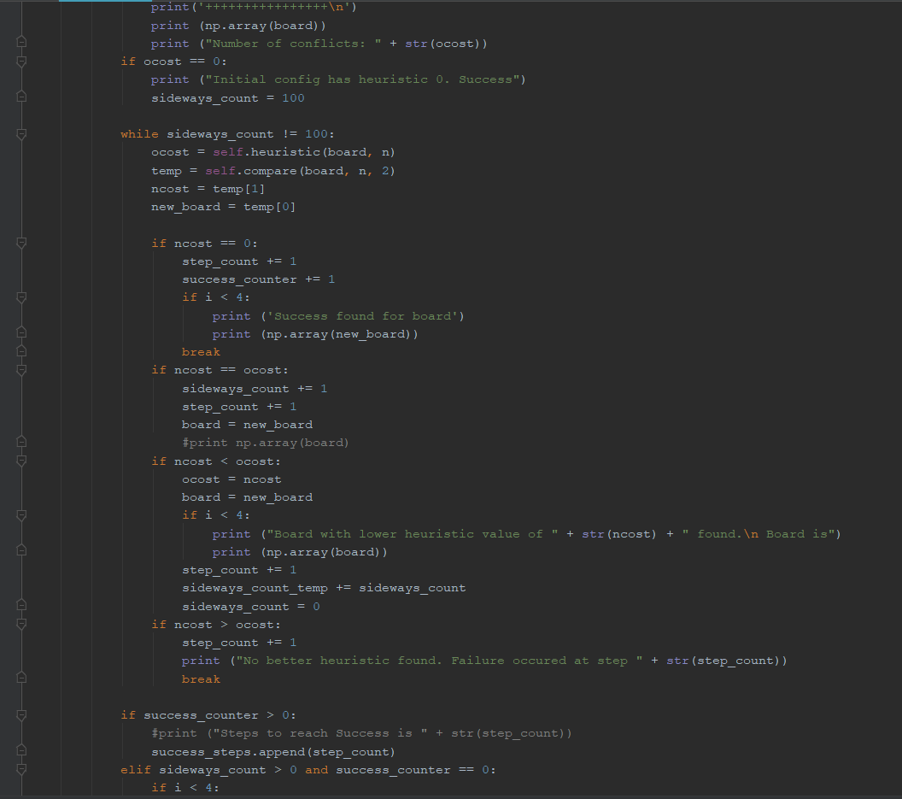

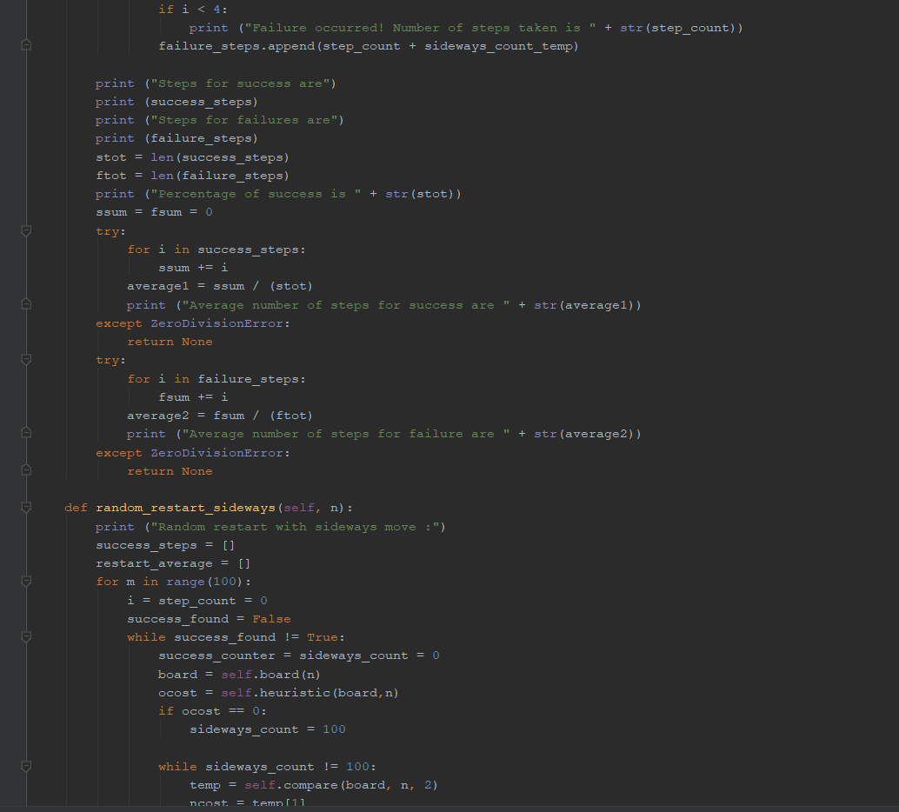 

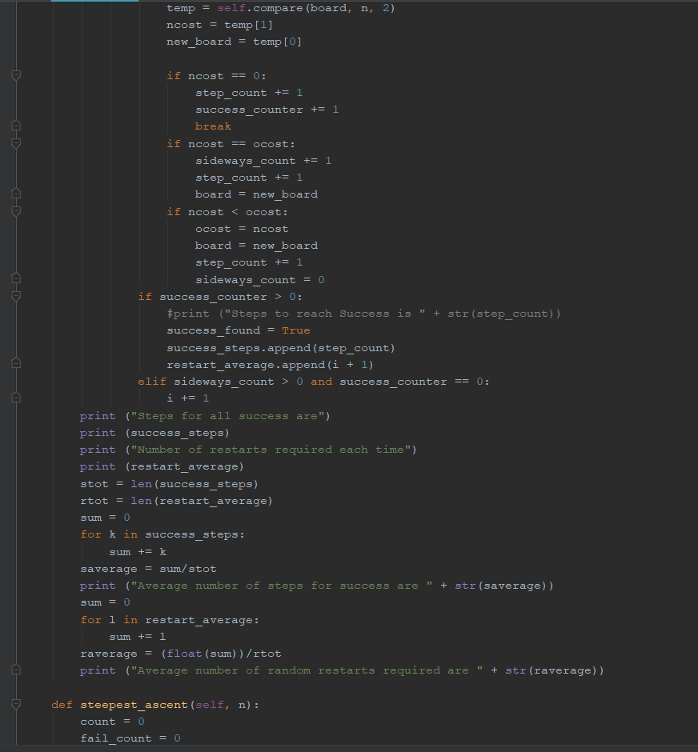

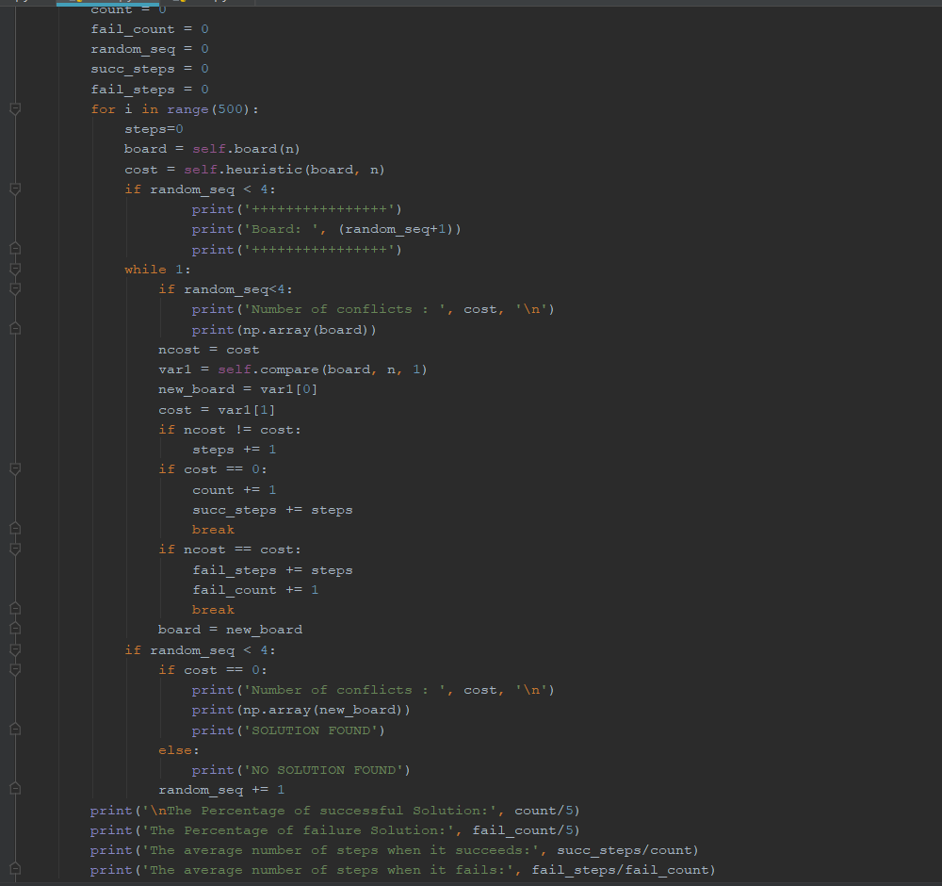

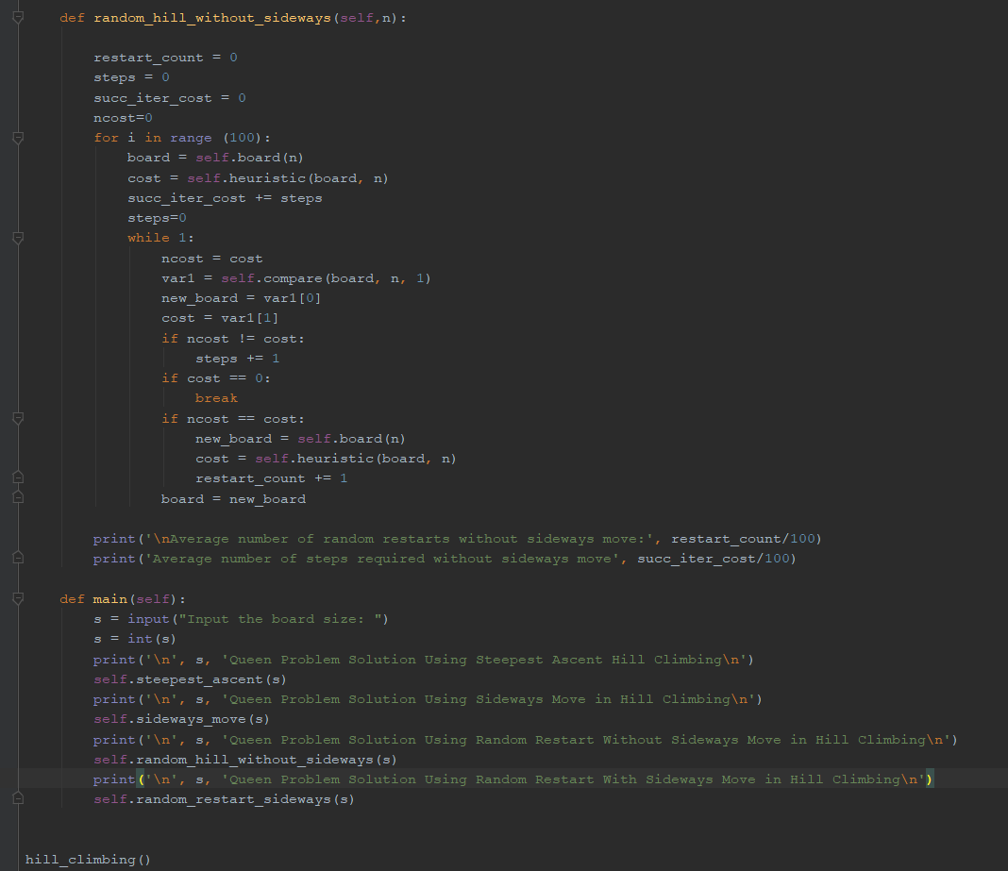

1. INPUT/OUTPUT-

Input the board size: 8

8 Queen Problem Solution Using Steepest Ascent Hill Climbing

++++++++++++++++

Board: 1

++++++++++++++++

Number of conflicts : 11

[[0 0 1 0 0 0 1 1]

[0 0 0 0 0 0 0 0]

[0 0 0 1 1 0 0 0]

[0 0 0 0 0 1 0 0]

[0 1 0 0 0 0 0 0]

[1 0 0 0 0 0 0 0]

[0 0 0 0 0 0 0 0]

[0 0 0 0 0 0 0 0]]

Number of conflicts : 7

[[0 0 1 0 0 0 1 1]

[0 0 0 0 0 0 0 0]

[0 0 0 1 0 0 0 0]

[0 0 0 0 0 1 0 0]

[0 1 0 0 0 0 0 0]

[1 0 0 0 0 0 0 0]

[0 0 0 0 1 0 0 0]

[0 0 0 0 0 0 0 0]]

Number of conflicts : 5

[[0 0 0 0 0 0 1 1]

[0 0 1 0 0 0 0 0]

[0 0 0 1 0 0 0 0]

[0 0 0 0 0 1 0 0]

[0 1 0 0 0 0 0 0]

[1 0 0 0 0 0 0 0]

[0 0 0 0 1 0 0 0]

[0 0 0 0 0 0 0 0]]

Number of conflicts : 3

[[0 0 0 0 0 0 1 1]

[0 0 1 0 0 0 0 0]

[0 0 0 0 0 0 0 0]

[0 0 0 0 0 1 0 0]

[0 1 0 0 0 0 0 0]

[1 0 0 0 0 0 0 0]

[0 0 0 0 1 0 0 0]

[0 0 0 1 0 0 0 0]]

Number of conflicts : 2

[[0 0 0 0 0 0 1 0]

[0 0 1 0 0 0 0 0]

[0 0 0 0 0 0 0 1]

[0 0 0 0 0 1 0 0]

[0 1 0 0 0 0 0 0]

[1 0 0 0 0 0 0 0]

[0 0 0 0 1 0 0 0]

[0 0 0 1 0 0 0 0]]

NO SOLUTION FOUND

++++++++++++++++

Board: 2

++++++++++++++++

Number of conflicts : 11

[[0 0 0 0 0 0 0 1]

[0 0 0 0 0 1 0 0]

[0 0 0 0 1 0 0 0]

[0 0 0 1 0 0 0 0]

[0 0 0 0 0 0 1 0]

[1 1 1 0 0 0 0 0]

[0 0 0 0 0 0 0 0]

[0 0 0 0 0 0 0 0]]

Number of conflicts : 6

[[0 0 0 0 0 0 0 1]

[0 0 0 0 0 1 0 0]

[0 0 0 0 1 0 0 0]

[0 0 0 1 0 0 0 0]

[0 0 0 0 0 0 1 0]

[1 0 1 0 0 0 0 0]

[0 0 0 0 0 0 0 0]

[0 1 0 0 0 0 0 0]]

Number of conflicts : 4

[[0 0 0 0 0 0 0 1]

[0 0 0 0 0 0 0 0]

[0 0 0 0 1 0 0 0]

[0 0 0 1 0 0 0 0]

[0 0 0 0 0 0 1 0]

[1 0 1 0 0 0 0 0]

[0 0 0 0 0 1 0 0]

[0 1 0 0 0 0 0 0]]

Number of conflicts : 2

[[0 0 0 0 0 0 0 1]

[0 0 1 0 0 0 0 0]

[0 0 0 0 1 0 0 0]

[0 0 0 1 0 0 0 0]

[0 0 0 0 0 0 1 0]

[1 0 0 0 0 0 0 0]

[0 0 0 0 0 1 0 0]

[0 1 0 0 0 0 0 0]]

Number of conflicts : 1

[[0 0 0 0 1 0 0 1]

[0 0 1 0 0 0 0 0]

[0 0 0 0 0 0 0 0]

[0 0 0 1 0 0 0 0]

[0 0 0 0 0 0 1 0]

[1 0 0 0 0 0 0 0]

[0 0 0 0 0 1 0 0]

[0 1 0 0 0 0 0 0]]

Number of conflicts : 0

[[0 0 0 0 1 0 0 0]

[0 0 1 0 0 0 0 0]

[0 0 0 0 0 0 0 1]

[0 0 0 1 0 0 0 0]

[0 0 0 0 0 0 1 0]

[1 0 0 0 0 0 0 0]

[0 0 0 0 0 1 0 0]

[0 1 0 0 0 0 0 0]]

SOLUTION FOUND

++++++++++++++++

Board: 3

++++++++++++++++

Number of conflicts : 12

[[0 0 0 0 0 1 0 1]

[0 0 0 0 0 0 1 0]

[1 0 1 0 0 0 0 0]

[0 1 0 0 1 0 0 0]

[0 0 0 1 0 0 0 0]

[0 0 0 0 0 0 0 0]

[0 0 0 0 0 0 0 0]

[0 0 0 0 0 0 0 0]]

Number of conflicts : 8

[[0 0 0 0 0 1 0 0]

[0 0 0 0 0 0 1 0]

[1 0 1 0 0 0 0 0]

[0 1 0 0 1 0 0 0]

[0 0 0 1 0 0 0 0]

[0 0 0 0 0 0 0 1]

[0 0 0 0 0 0 0 0]

[0 0 0 0 0 0 0 0]]

Number of conflicts : 5

[[0 0 0 0 0 1 0 0]

[0 0 0 0 0 0 1 0]

[1 0 1 0 0 0 0 0]

[0 0 0 0 1 0 0 0]

[0 0 0 1 0 0 0 0]

[0 0 0 0 0 0 0 1]

[0 0 0 0 0 0 0 0]

[0 1 0 0 0 0 0 0]]

Number of conflicts : 3

[[0 0 0 0 0 1 1 0]

[0 0 0 0 0 0 0 0]

[1 0 1 0 0 0 0 0]

[0 0 0 0 1 0 0 0]

[0 0 0 1 0 0 0 0]

[0 0 0 0 0 0 0 1]

[0 0 0 0 0 0 0 0]

[0 1 0 0 0 0 0 0]]

Number of conflicts : 2

[[0 0 0 0 0 1 1 0]

[0 0 0 0 0 0 0 0]

[1 0 1 0 0 0 0 0]

[0 0 0 0 1 0 0 0]

[0 0 0 0 0 0 0 0]

[0 0 0 0 0 0 0 1]

[0 0 0 1 0 0 0 0]

[0 1 0 0 0 0 0 0]]

Number of conflicts : 1

[[0 0 0 0 0 1 1 0]

[1 0 0 0 0 0 0 0]

[0 0 1 0 0 0 0 0]

[0 0 0 0 1 0 0 0]

[0 0 0 0 0 0 0 0]

[0 0 0 0 0 0 0 1]

[0 0 0 1 0 0 0 0]

[0 1 0 0 0 0 0 0]]

NO SOLUTION FOUND

++++++++++++++++

Board: 4

++++++++++++++++

Number of conflicts : 10

[[0 0 0 0 0 0 0 0]

[0 0 0 0 0 0 0 0]

[0 0 0 0 0 0 0 0]

[0 1 0 0 0 0 0 0]

[0 0 0 0 0 0 0 1]

[0 0 0 0 0 0 1 0]

[1 0 0 0 0 0 0 0]

[0 0 1 1 1 1 0 0]]

Number of conflicts : 6

[[0 0 0 0 1 0 0 0]

[0 0 0 0 0 0 0 0]

[0 0 0 0 0 0 0 0]

[0 1 0 0 0 0 0 0]

[0 0 0 0 0 0 0 1]

[0 0 0 0 0 0 1 0]

[1 0 0 0 0 0 0 0]

[0 0 1 1 0 1 0 0]]

Number of conflicts : 4

[[0 0 0 0 1 0 0 0]

[0 1 0 0 0 0 0 0]

[0 0 0 0 0 0 0 0]

[0 0 0 0 0 0 0 0]

[0 0 0 0 0 0 0 1]

[0 0 0 0 0 0 1 0]

[1 0 0 0 0 0 0 0]

[0 0 1 1 0 1 0 0]]

Number of conflicts : 2

[[0 0 0 0 1 0 0 0]

[0 1 0 0 0 0 0 0]

[0 0 0 0 0 0 0 0]

[0 0 1 0 0 0 0 0]

[0 0 0 0 0 0 0 1]

[0 0 0 0 0 0 1 0]

[1 0 0 0 0 0 0 0]

[0 0 0 1 0 1 0 0]]

Number of conflicts : 1

[[0 0 0 0 1 0 0 0]

[0 1 0 0 0 0 0 0]

[0 0 0 0 0 0 0 1]

[0 0 1 0 0 0 0 0]

[0 0 0 0 0 0 0 0]

[0 0 0 0 0 0 1 0]

[1 0 0 0 0 0 0 0]

[0 0 0 1 0 1 0 0]]

NO SOLUTION FOUND

The Percentage of successful Solution: 15.0

The Percentage of failure Solution: 85.0

The average number of steps when it succeeds: 4.066666666666666

The average number of steps when it fails: 3.032941176470588

8 Queen Problem Solution Using Sideways Move in Hill Climbing

Sideways move :

++++++++++++++++

Board Number 1

++++++++++++++++

[[0 0 0 0 1 0 0 0]

[0 0 0 0 0 0 1 0]

[0 0 0 0 0 0 0 0]

[0 0 0 0 0 0 0 0]

[0 0 0 0 0 0 0 0]

[0 0 0 1 0 0 0 0]

[0 0 0 0 0 0 0 1]

[1 1 1 0 0 1 0 0]]

Number of conflicts: 9

Board with lower heuristic value of 5 found.

Board is

[[0 0 0 0 1 0 0 0]

[0 0 0 0 0 0 1 0]

[0 0 0 0 0 0 0 0]

[1 0 0 0 0 0 0 0]

[0 0 0 0 0 0 0 0]

[0 0 0 1 0 0 0 0]

[0 0 0 0 0 0 0 1]

[0 1 1 0 0 1 0 0]]

Board with lower heuristic value of 3 found.

Board is

[[0 0 0 0 1 0 0 0]

[0 0 0 0 0 0 1 0]

[0 0 0 0 0 0 0 0]

[1 0 0 0 0 0 0 0]

[0 1 0 0 0 0 0 0]

[0 0 0 1 0 0 0 0]

[0 0 0 0 0 0 0 1]

[0 0 1 0 0 1 0 0]]

Board with lower heuristic value of 2 found.

Board is

[[0 0 0 0 1 0 0 0]

[0 0 0 0 0 0 1 0]

[0 0 0 0 0 1 0 0]

[1 0 0 0 0 0 0 0]

[0 1 0 0 0 0 0 0]

[0 0 0 1 0 0 0 0]

[0 0 0 0 0 0 0 1]

[0 0 1 0 0 0 0 0]]

Board with lower heuristic value of 1 found.

Board is

[[0 0 0 0 1 0 1 0]

[1 0 0 0 0 0 0 0]

[0 0 0 0 0 1 0 0]

[0 0 0 0 0 0 0 0]

[0 1 0 0 0 0 0 0]

[0 0 0 1 0 0 0 0]

[0 0 0 0 0 0 0 1]

[0 0 1 0 0 0 0 0]]

Success found for board

[[0 0 0 0 1 0 0 0]

[0 1 0 0 0 0 0 0]

[0 0 0 0 0 1 0 0]

[1 0 0 0 0 0 0 0]

[0 0 0 0 0 0 1 0]

[0 0 0 1 0 0 0 0]

[0 0 0 0 0 0 0 1]

[0 0 1 0 0 0 0 0]]

++++++++++++++++

Board Number 2

++++++++++++++++

[[0 0 0 0 0 0 0 0]

[0 1 0 0 1 0 0 0]

[0 0 0 0 0 0 0 1]

[0 0 0 0 0 0 1 0]

[0 0 0 1 0 0 0 0]

[0 0 1 0 0 0 0 0]

[1 0 0 0 0 1 0 0]

[0 0 0 0 0 0 0 0]]

Number of conflicts: 6

Board with lower heuristic value of 4 found.

Board is

[[0 0 0 0 0 0 0 0]

[0 1 0 0 1 0 0 0]

[0 0 0 0 0 0 0 1]

[0 0 0 0 0 0 1 0]

[0 0 0 0 0 0 0 0]

[0 0 1 0 0 0 0 0]

[1 0 0 0 0 1 0 0]

[0 0 0 1 0 0 0 0]]

Board with lower heuristic value of 2 found.

Board is

[[0 0 0 0 1 0 0 0]

[0 1 0 0 0 0 0 0]

[0 0 0 0 0 0 0 1]

[0 0 0 0 0 0 1 0]

[0 0 0 0 0 0 0 0]

[0 0 1 0 0 0 0 0]

[1 0 0 0 0 1 0 0]

[0 0 0 1 0 0 0 0]]

Board with lower heuristic value of 1 found.

Board is

[[0 0 0 0 1 0 0 0]

[0 0 0 0 0 0 0 1]

[0 1 0 0 0 0 0 0]

[0 0 0 0 0 0 1 0]

[0 0 0 0 0 1 0 0]

[0 0 1 0 0 0 0 0]

[1 0 0 0 0 0 0 0]

[0 0 0 1 0 0 0 0]]

Success found for board

[[0 0 0 1 0 0 0 0]

[0 0 0 0 0 0 0 1]

[1 0 0 0 0 0 0 0]

[0 0 1 0 0 0 0 0]

[0 0 0 0 0 1 0 0]

[0 1 0 0 0 0 0 0]

[0 0 0 0 0 0 1 0]

[0 0 0 0 1 0 0 0]]

++++++++++++++++

Board Number 3

++++++++++++++++

[[0 0 0 0 0 0 0 0]

[0 0 0 0 0 0 0 0]

[1 1 0 0 0 0 0 0]

[0 0 0 0 1 0 0 1]

[0 0 0 0 0 0 1 0]

[0 0 1 0 0 1 0 0]

[0 0 0 1 0 0 0 0]

[0 0 0 0 0 0 0 0]]

Number of conflicts: 8

Board with lower heuristic value of 5 found.

Board is

[[0 0 0 0 0 0 0 0]

[0 0 0 0 0 0 0 1]

[1 1 0 0 0 0 0 0]

[0 0 0 0 1 0 0 0]

[0 0 0 0 0 0 1 0]

[0 0 1 0 0 1 0 0]

[0 0 0 1 0 0 0 0]

[0 0 0 0 0 0 0 0]]

Board with lower heuristic value of 3 found.

Board is

[[0 0 0 0 0 1 0 0]

[0 0 0 0 0 0 0 1]

[1 1 0 0 0 0 0 0]

[0 0 0 0 1 0 0 0]

[0 0 0 0 0 0 1 0]

[0 0 1 0 0 0 0 0]

[0 0 0 1 0 0 0 0]

[0 0 0 0 0 0 0 0]]

Board with lower heuristic value of 2 found.

Board is

[[0 0 0 0 0 1 0 0]

[0 0 0 0 0 0 0 1]

[1 1 0 0 0 0 0 0]

[0 0 0 0 1 0 0 0]

[0 0 0 0 0 0 1 0]

[0 0 0 0 0 0 0 0]

[0 0 0 1 0 0 0 0]

[0 0 1 0 0 0 0 0]]

Board with lower heuristic value of 1 found.

Board is

[[0 0 0 0 0 1 0 0]

[0 0 0 0 0 0 0 1]

[1 0 0 0 0 0 0 0]

[0 0 0 0 1 0 0 0]

[0 0 0 0 0 0 1 0]

[0 1 0 0 0 0 0 0]

[0 0 0 1 0 0 0 0]

[0 0 1 0 0 0 0 0]]

Success found for board

[[0 0 0 1 0 0 0 0]

[0 0 0 0 0 0 0 1]

[1 0 0 0 0 0 0 0]

[0 0 0 0 1 0 0 0]

[0 0 0 0 0 0 1 0]

[0 1 0 0 0 0 0 0]

[0 0 0 0 0 1 0 0]

[0 0 1 0 0 0 0 0]]

++++++++++++++++

Board Number 4

++++++++++++++++

[[0 0 0 0 0 1 0 0]

[0 0 0 0 0 0 0 0]

[0 0 1 0 0 0 0 0]

[1 0 0 0 1 0 0 0]

[0 1 0 1 0 0 1 0]

[0 0 0 0 0 0 0 0]

[0 0 0 0 0 0 0 0]

[0 0 0 0 0 0 0 1]]

Number of conflicts: 8

Board with lower heuristic value of 4 found.

Board is

[[0 0 0 0 0 1 0 0]

[0 0 0 0 0 0 0 0]

[0 0 1 0 0 0 0 0]

[1 0 0 0 1 0 0 0]

[0 0 0 1 0 0 1 0]

[0 1 0 0 0 0 0 0]

[0 0 0 0 0 0 0 0]

[0 0 0 0 0 0 0 1]]

Board with lower heuristic value of 3 found.

Board is

[[0 0 0 0 0 1 0 0]

[0 0 0 0 0 0 0 0]

[0 0 1 0 0 0 0 0]

[1 0 0 0 0 0 0 0]

[0 0 0 1 0 0 1 0]

[0 1 0 0 0 0 0 0]

[0 0 0 0 1 0 0 0]

[0 0 0 0 0 0 0 1]]

Board with lower heuristic value of 2 found.

Board is

[[0 0 0 0 0 1 0 0]

[0 0 0 0 0 0 0 0]

[0 0 1 0 0 0 0 0]

[1 0 0 0 0 0 0 0]

[0 0 0 1 0 0 0 0]

[0 1 0 0 0 0 1 0]

[0 0 0 0 1 0 0 0]

[0 0 0 0 0 0 0 1]]

Board with lower heuristic value of 1 found.

Board is

[[0 0 0 0 0 1 0 0]

[0 0 0 0 0 0 0 1]

[0 0 1 0 0 0 0 0]

[1 0 0 0 0 0 0 0]

[0 0 0 1 0 0 0 0]

[0 1 0 0 0 0 1 0]

[0 0 0 0 1 0 0 0]

[0 0 0 0 0 0 0 0]]

Success found for board

[[0 0 0 0 0 1 0 0]

[0 1 0 0 0 0 0 0]

[0 0 0 0 0 0 1 0]

[1 0 0 0 0 0 0 0]

[0 0 0 1 0 0 0 0]

[0 0 0 0 0 0 0 1]

[0 0 0 0 1 0 0 0]

[0 0 1 0 0 0 0 0]]

Steps for success are

[13, 36, 6, 17, 39, 19, 3, 27, 6, 5, 5, 7, 25, 9, 58, 23, 4, 5, 6, 32, 4, 4, 79, 12, 5, 53, 57, 23, 8, 101, 19, 76, 13, 11, 22, 80, 14, 12, 97, 4, 30, 25, 6, 11, 10, 66, 31, 3, 30, 23, 17, 3, 11, 31, 6, 27, 10, 22, 6, 7, 10, 74, 4, 21, 7, 47, 23, 9, 21, 10, 7, 19, 28, 5, 5, 38, 9, 3, 13, 5, 5, 14, 26, 27, 39, 28, 45, 22, 13, 9, 5, 42, 13]

Steps for failures are

[103, 104, 106, 103, 104, 103, 109]

Percentage of success is 93

Average number of steps for success are 22.150537634408604

Average number of steps for failure are 104.57142857142857

8 Queen Problem Solution Using Random Restart Without Sideways Move in Hill Climbing

Average number of random restarts without sideways move: 5.36

Average number of steps required without sideways move 20.0

8 Queen Problem Solution Using Random Restart With Sideways Move in Hill Climbing

Random restart with sideways move :

Steps for all success are

[5, 4, 9, 46, 7, 19, 27, 4, 15, 17, 4, 8, 17, 5, 9, 15, 22, 4, 6, 27, 5, 3, 33, 16, 9, 4, 5, 19, 10, 107, 98, 22, 50, 4, 5, 6, 5, 22, 79, 3, 4, 291, 5, 54, 6, 7, 4, 18, 17, 16, 14, 36, 69, 5, 5, 6, 17, 36, 108, 141, 12, 7, 6, 22, 9, 120, 7, 112, 3, 8, 5, 6, 4, 6, 7, 3, 9, 21, 3, 8, 14, 14, 18, 59, 41, 9, 85, 39, 76, 3, 28, 4, 9, 4, 21, 13, 34, 5, 12, 8]

Number of restarts required each time

[1, 1, 1, 1, 1, 1, 1, 1, 1, 1, 1, 1, 1, 1, 1, 1, 1, 1, 1, 1, 1, 1, 1, 1, 1, 1, 1, 1, 1, 2, 1, 1, 1, 1, 1, 1, 1, 1, 1, 1, 1, 3, 1, 1, 1, 1, 1, 1, 1, 1, 1, 1, 1, 1, 1, 1, 1, 1, 2, 2, 1, 1, 1, 1, 1, 2, 1, 2, 1, 1, 1, 1, 1, 1, 1, 1, 1, 1, 1, 1, 1, 1, 1, 1, 1, 1, 1, 1, 1, 1, 1, 1, 1, 1, 1, 1, 1, 1, 1, 1]

Average number of steps for success are 25.08

Average number of random restarts required are 1.07

1. Summary of the Result(8-Queen problem)-
2. Hill Climbing with Steepest Ascent-

The Percentage of successful Solution: 15.0

The Percentage of failure Solution: 85.0

The average number of steps when it succeeds: 4.066666666666666

The average number of steps when it fails: 3.032941176470588

1. Hill Climbing Using Sideways Move-

Percentage of success is 93

Percentage of failure is 7

Average number of steps for success are 22.150537634408604

Average number of steps for failure are 104.57142857142857

1. Hill Climbing using Random Restart without Sideways move-

Average number of random restarts without sideways move: 5.36

Average number of steps required without sideways move 20.0

1. Hill Climbing using Random Restart with Sideways move-

Average number of random restarts required are 1.07

Average number of steps for success are 25.08